1. 測試內容：

測試 Meter table之Meter Identifier是否能由Meter Entry之json檔指定。

1. 測試環境架構：

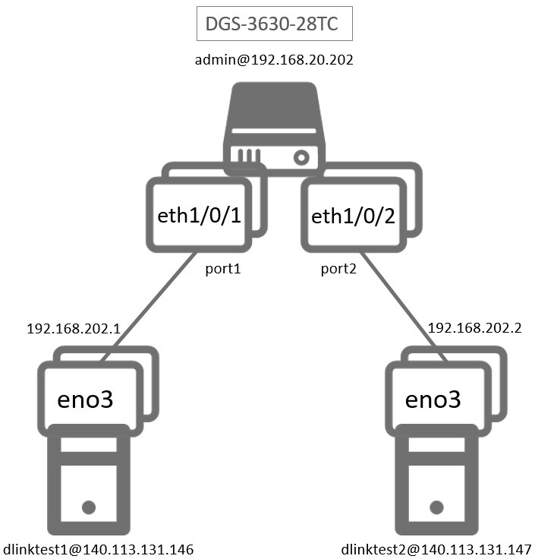

1. 測試環境組態：

* SDN controller: ONOS 1.15.0
* Switch: DGS-3630
* Hosts:
  + ubuntu 16.04.5 LTS
  + dlinktest1(實體機)
    - IP: 192.168.202.1
    - MAC: d0:94:66:5d:5e:08/64
    - Port: 1
  + dlinktest2(實體機)
    - IP: 192.168.202.2
    - MAC: d0:94:66:5c:45:20/64
    - Port: 2
* Apps:

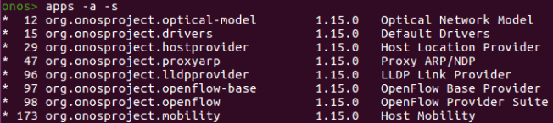

1. 使用之JSON文件：
   * Meter Rule: (附檔：kbps6.json)

|  |
| --- |
| {  "deviceId": "of:000078321bdf4000",  "id": 6,  "unit": "KB_PER_SEC",  "burst": true,  "bands": [  {  "type": "DROP",  "rate": "10240",  "burstSize": "10240"  }  ]  } |

* + Meter Rule: (附檔：kbps7.json)

|  |
| --- |
| {  "deviceId": "of:000078321bdf4000",  "id": 7,  "unit": "KB_PER_SEC",  "burst": true,  "bands": [  {  "type": "DROP",  "rate": "10240",  "burstSize": "10240"  }  ]  } |

1. 測試步驟：
2. ONOS GUI: Meter View



1. Switch CLI:

* "id=1" and “id=2” are not as the installed meter entries as set (set “id=6” and “id=7”)

|  |
| --- |
| Switch# show openflow meter-config |

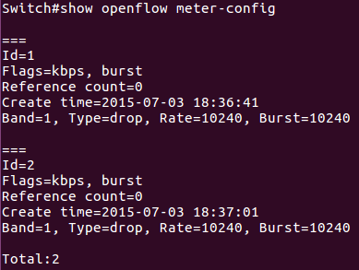

1. ONOS Log:



1. 測試結果：

Meter table之Meter Identifier不能由Meter Entry之json檔指定。